UNIVERSITY OF COMPUTER STUDIES (PATHEIN)
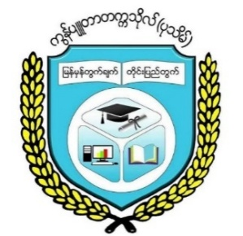

Project Report on Meeting App System
2024-2025 Academic Year
Fourth Year
CST-4211(Parallel and Distributed Computing) Project
Group - V

Supervised By :
Dr.Khin Lay Thwin
Professor
Faculty of Computer Science
Dr. Hnin Cherry
Lecturer
Faculty of Computer Science
Submitted By
- Mg Myo Sett Paing (Leader) VIIICS-37
- Mg Oakkar Kyaw VIIICS-13
- Mg Kyaw Thet Hmue VIIICS-14
- Mg Kaung Htet Swe VIIICS-17
- Ma Thazin Aung VIIICS-21
- Ma Yamin Thaw VIIICS-32
- Mg Ye Min Aung VIIICS-36
- Mg Phyo Zayar Lin VIIICS-39
- Mg Nyi Min Zan VIIICS-40
- Ma Khin Yadanar Aung VIIICS-46
September, 2025
Contents
No. | Description | Page
1. | Acknowledgements | 1
2 | Abstract | 2
3. | Introduction | 3
4. | Background Theory | 4
5. | Implementation | 5
 | 5.1 Client-Side | 5
 | 5.2 Server-Side | 6
6. | Conclusion | 11
7. | References | 12

List of Figures
No. | Description | Page
1 | Figure (5.1) Project Compilation and Packaging | 8
2 | Figure (5.2) Start RMI server | 8
3 | Figure (5.3) Tomcat Server Deployment | 9
4 | Figure (5.4) Application Access Point | 9
5 | Figure (5.5) Application Main Interface | 10

